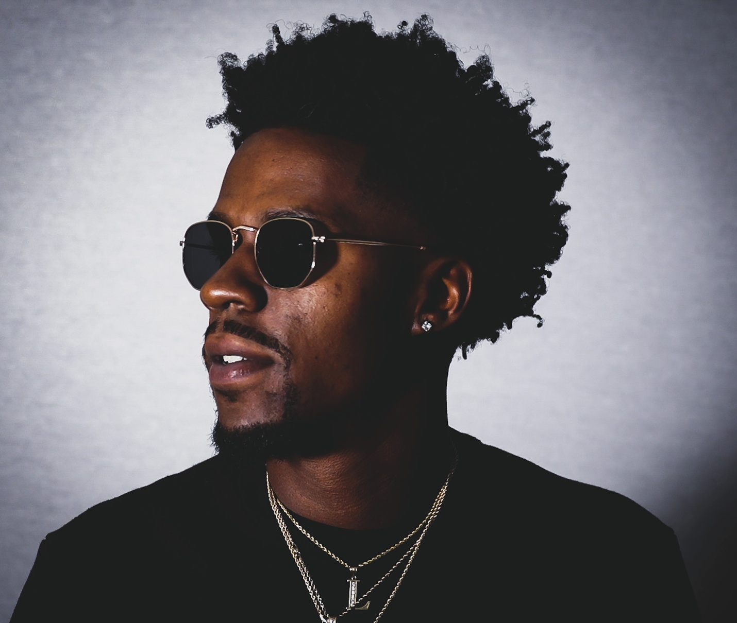
Twan Luv Lives in “The Moment”
CONWAY, SC - South Carolina native Twan Luv teases his upcoming EP Luvrday with new single “The Moment,” giving a glimmer of the authenticity to come.
Luv can’t remember a time he wasn’t singing and dancing. “Me and my brothers were always dancing. That was at the time when Kris Kross was hot and we used to wear our coats backwards. I always had the mic and my brothers would be my backup dancers,” he laughs, remembering all the talent shows that lit his way as well. Listening to rap and R&B greats like Lil Wayne, Trey Songz, Drake, Jodeci and Nipsey Hussle helped inform Luv’s soulful style.
But being soulful also comes naturally to Luv. Born the day after Valentine’s Day to a father named Ron Luv, the rapper’s always had themes of love and destiny on his mind. “The Moment” encapsulates pivotal moments in listener’s lives. “Basically it's a different moment. Everybody has a moment in life, and it's what you do with it. Are you going to stand up to the moment and fight it through to the other side? Once I get my moment, I'm going all in,” Luv declares.
Luv writes a lot of his music with women in mind, and one aspect of “The Moment” is being prepared to meet the right one. “A real woman is not going to just settle for anything, so you gotta be prepared for that. There's only a window, and that window could close any moment. When I say 'the moment,' the moment is any moment in life, no matter what it is. Sometimes to us it looks like a long time. In the Bible it says that one day to God is thousands of years. We gotta look at that. We only get a moment, so you have to leave your mark,” the artist explains.
“The Moment” appears on his forthcoming EP Luvrday. For this release, Luv did everything himself so he’d make a truly authentic debut. “It's just me. It's gonna give people a chance to know me and what luvrday is so they can know when they're having luvrdays. A luvrday is a day when you're feeling good, you're looking good, everything is great all day. If a person has a significant other--y'all are on the same energy, great energy. It's a day when you say ‘This was a day with so much love!’”
Twan Luv hopes his music can not only bring on the luvrdays, but help his fans live in the moment when they do.
https://www.instagram.com/luverday
https://twitter.com/twan_luv
https://www.facebook.com/dmond.allen

"The Moment"
https://soulspazm.ffm.to/themoment

© Starlight PR

